C:\Program Files\Microsoft Office\Media\CntCD1\ClipArt1\j0078733.wmfC:\Documents and Settings\Angela Gammell\Local Settings\Temporary Internet Files\Content.IE5\6PYTW5O3\MC900078738[1].wmf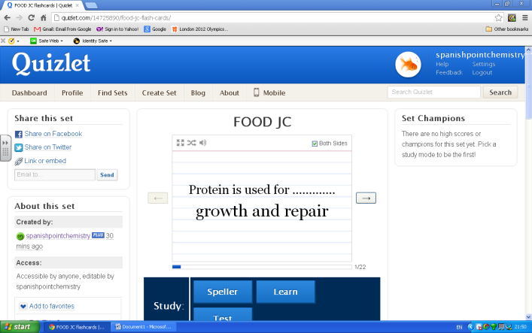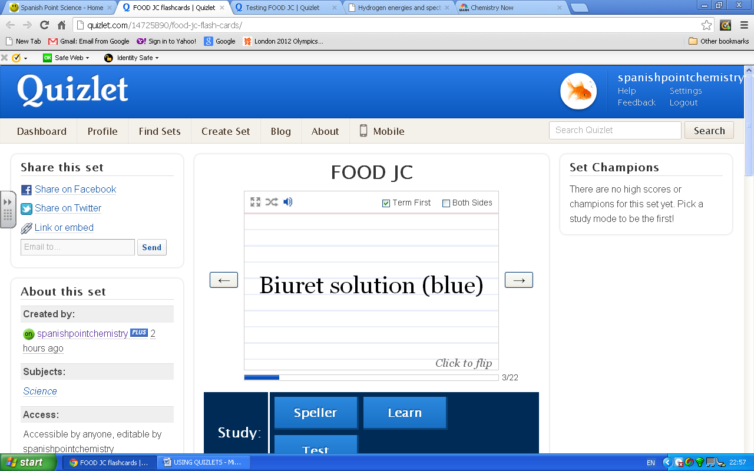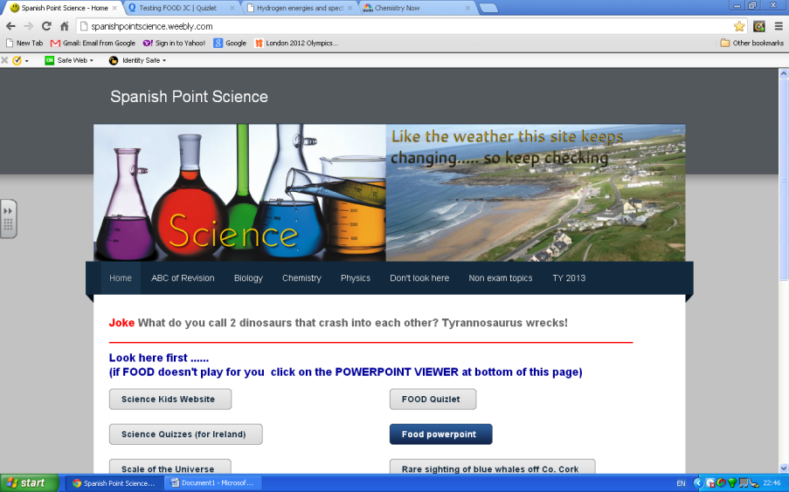USING QUIZLETS

Step 4

Hear each flashcard by clicking the speaker.

Step 3

Click here to go through all the flashcards

Step 2

Click here to get the TERM and its meaning together or separately.

Step 1

Go to Spanish Point Science

And click here

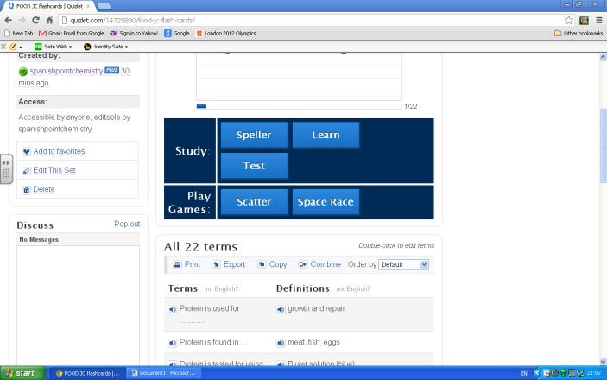

Step 6

Click here to test yourself

Step 5

Guess what this one does!

P.T.O 🡪 🡪 🡪 🡪

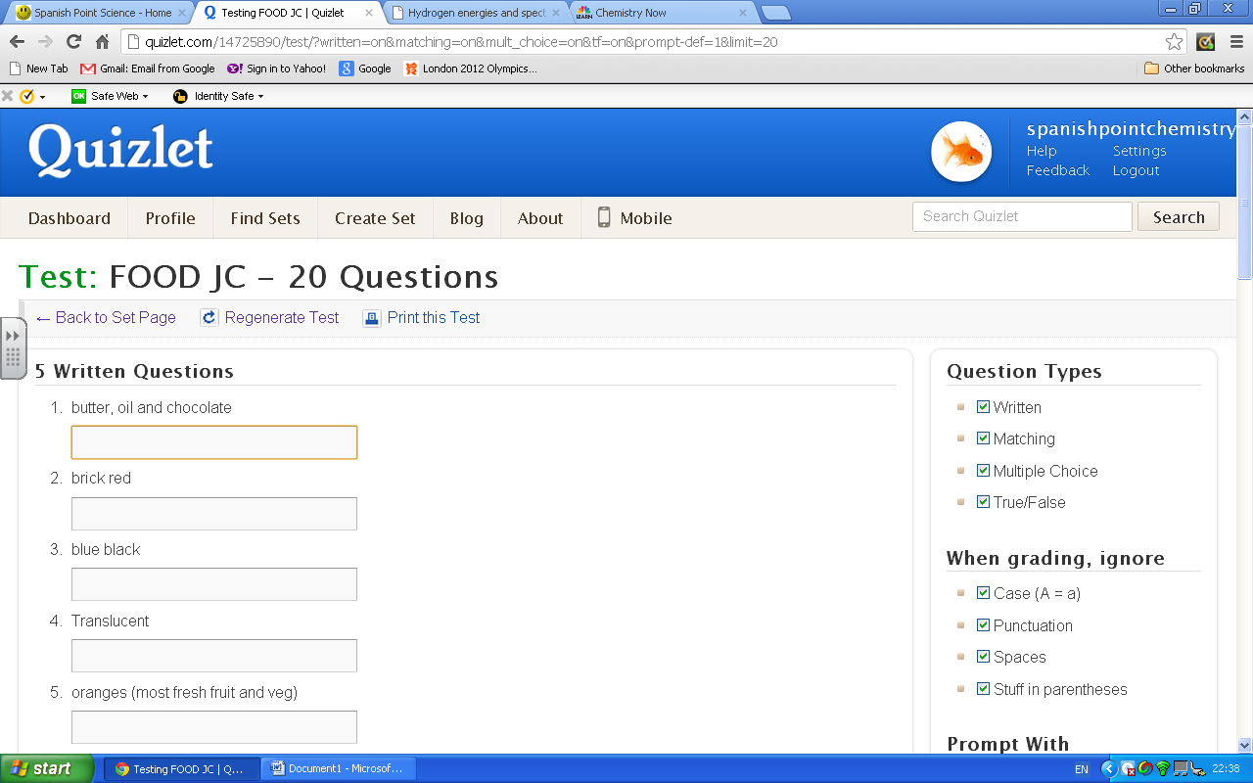C:\Program Files\Microsoft Office\Media\CntCD1\ClipArt1\j0078709.wmfC:\Program Files\Microsoft Office\Media\CntCD1\ClipArt1\j0078624.wmfC:\Program Files\Microsoft Office\Media\CntCD1\ClipArt1\j0078629.wmf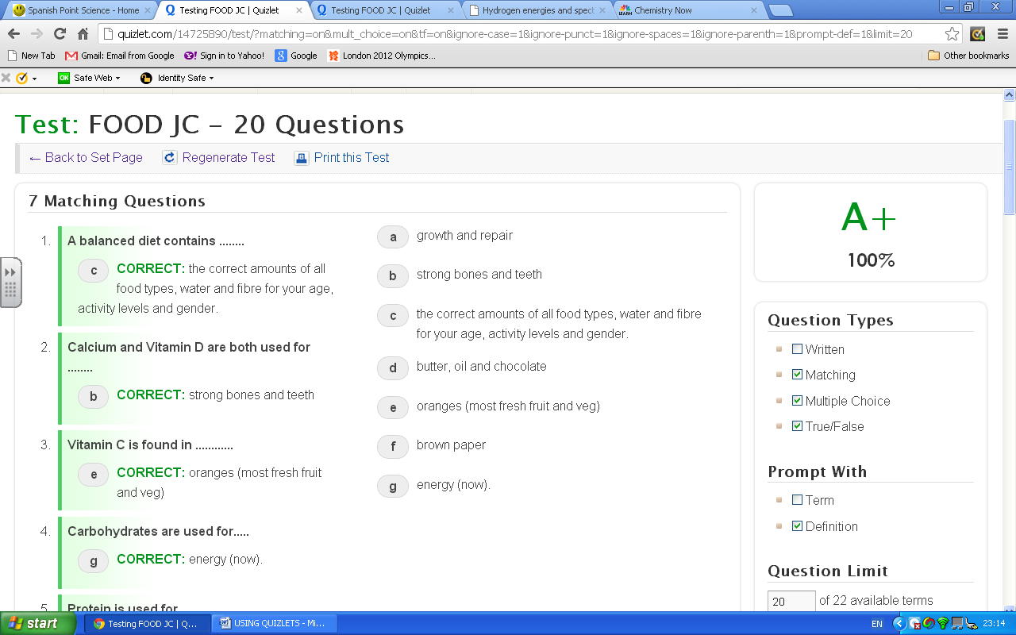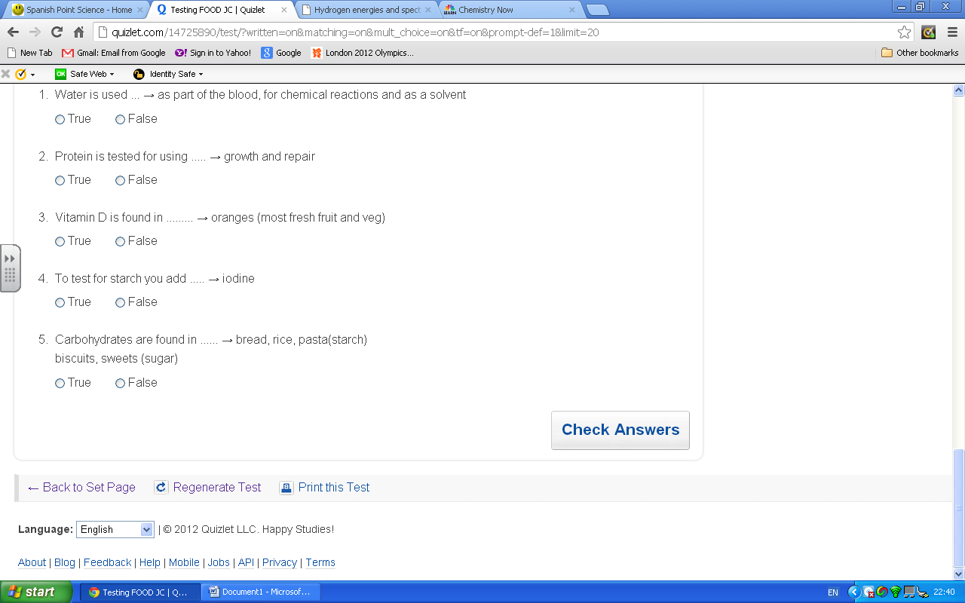

7 Un-tick here

Your score!

To use Quizlets on your smart phone

* Download a flashcard reader app – there are lots of free ones.
* Go to Spanish Point Science as shown above or….
* Put *spanishpointchemistry* into the quizlets search -to be sure of getting our ones.

9

All done?

Click here

8

And then click here