4.1 (b) To conduct a qualitative test for fat
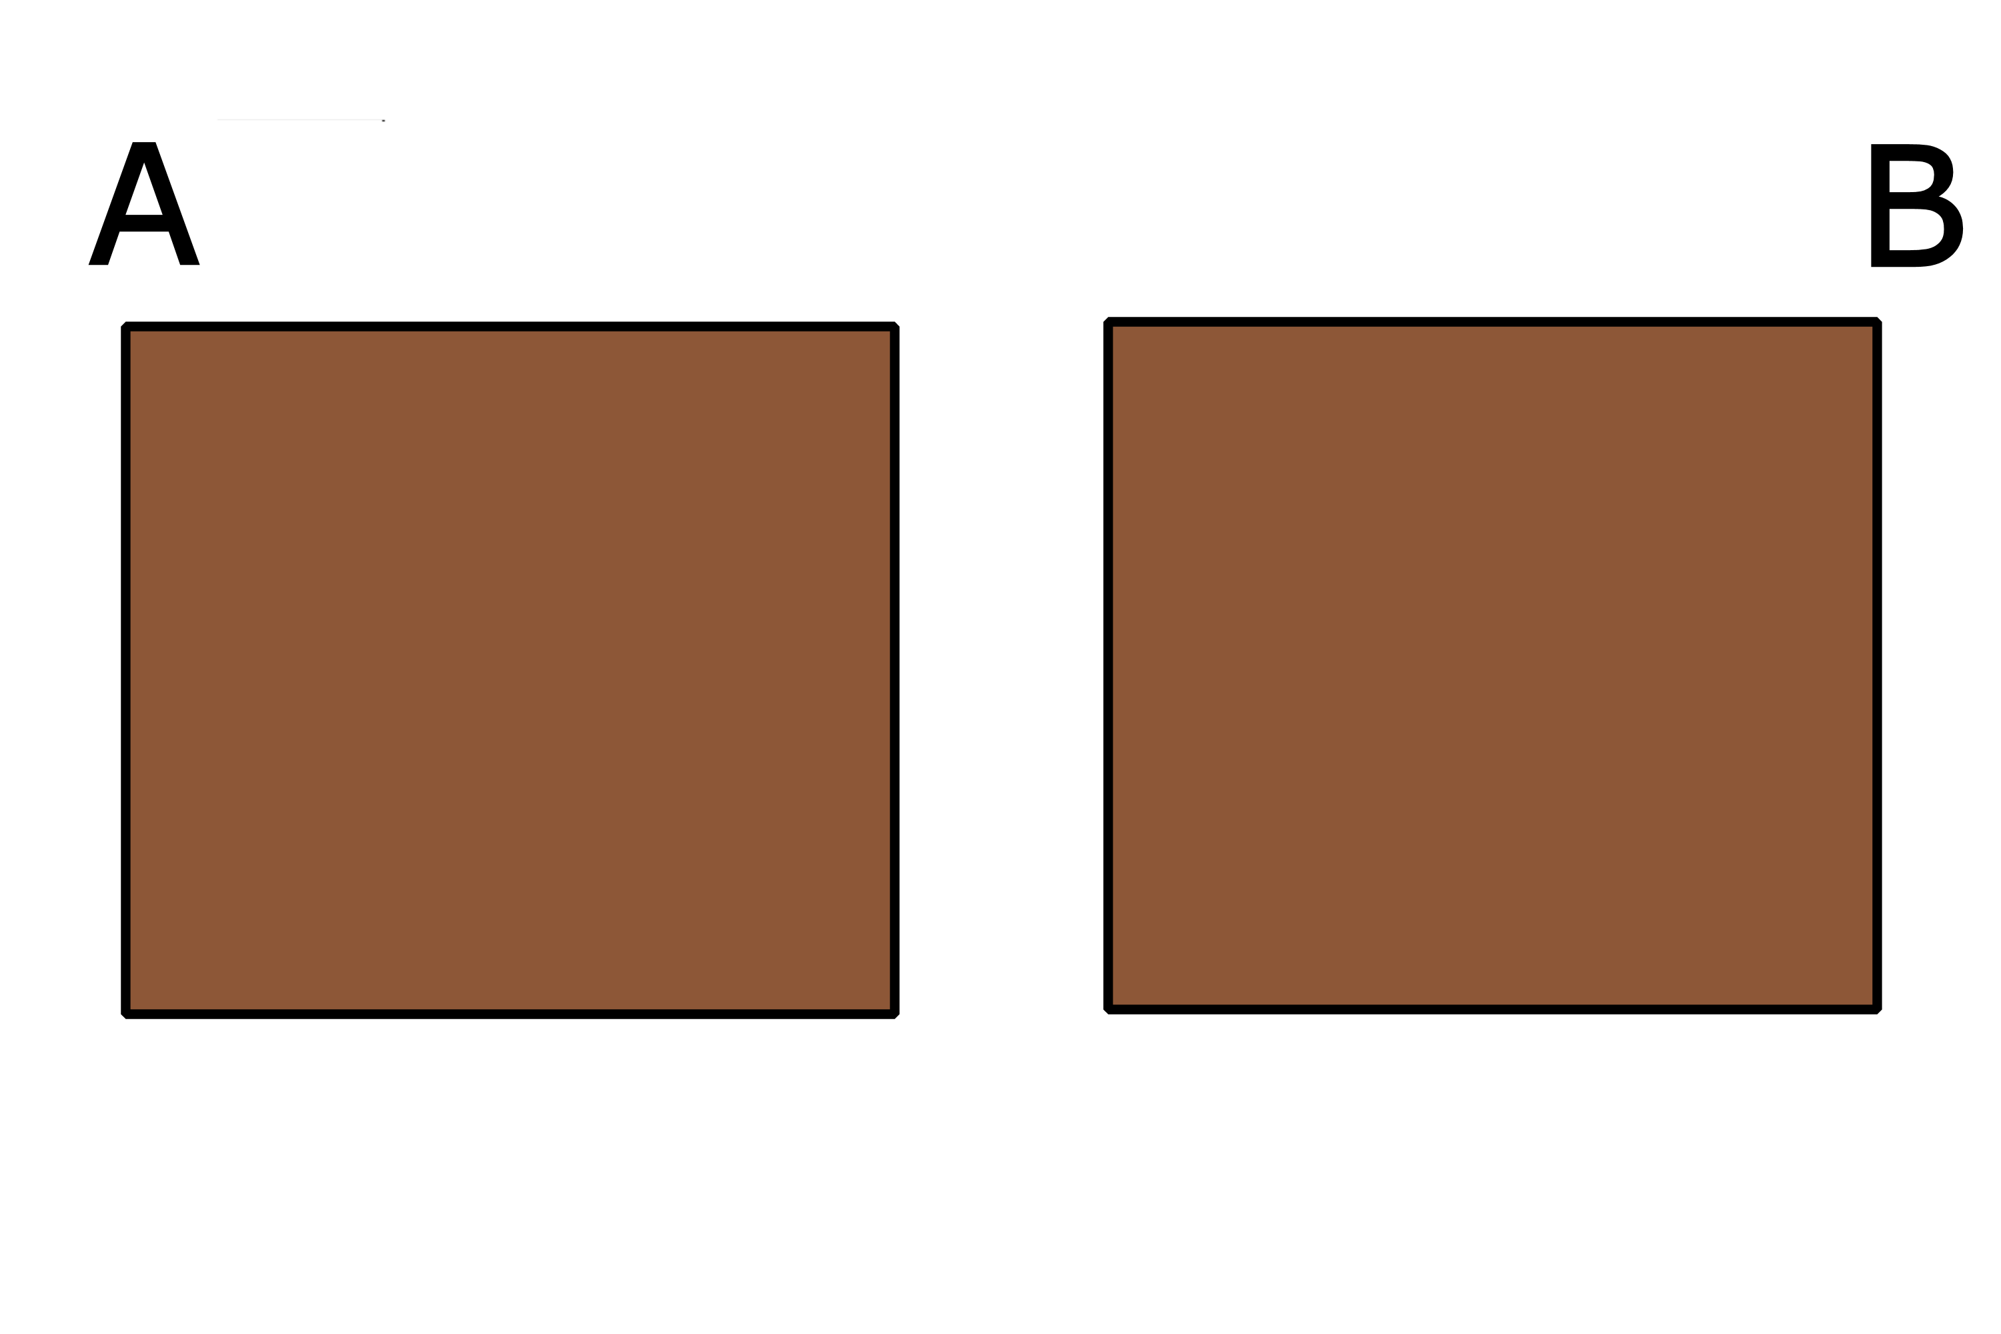
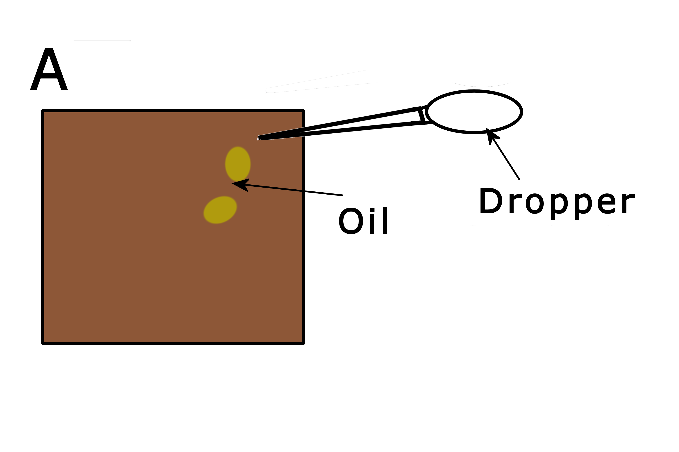
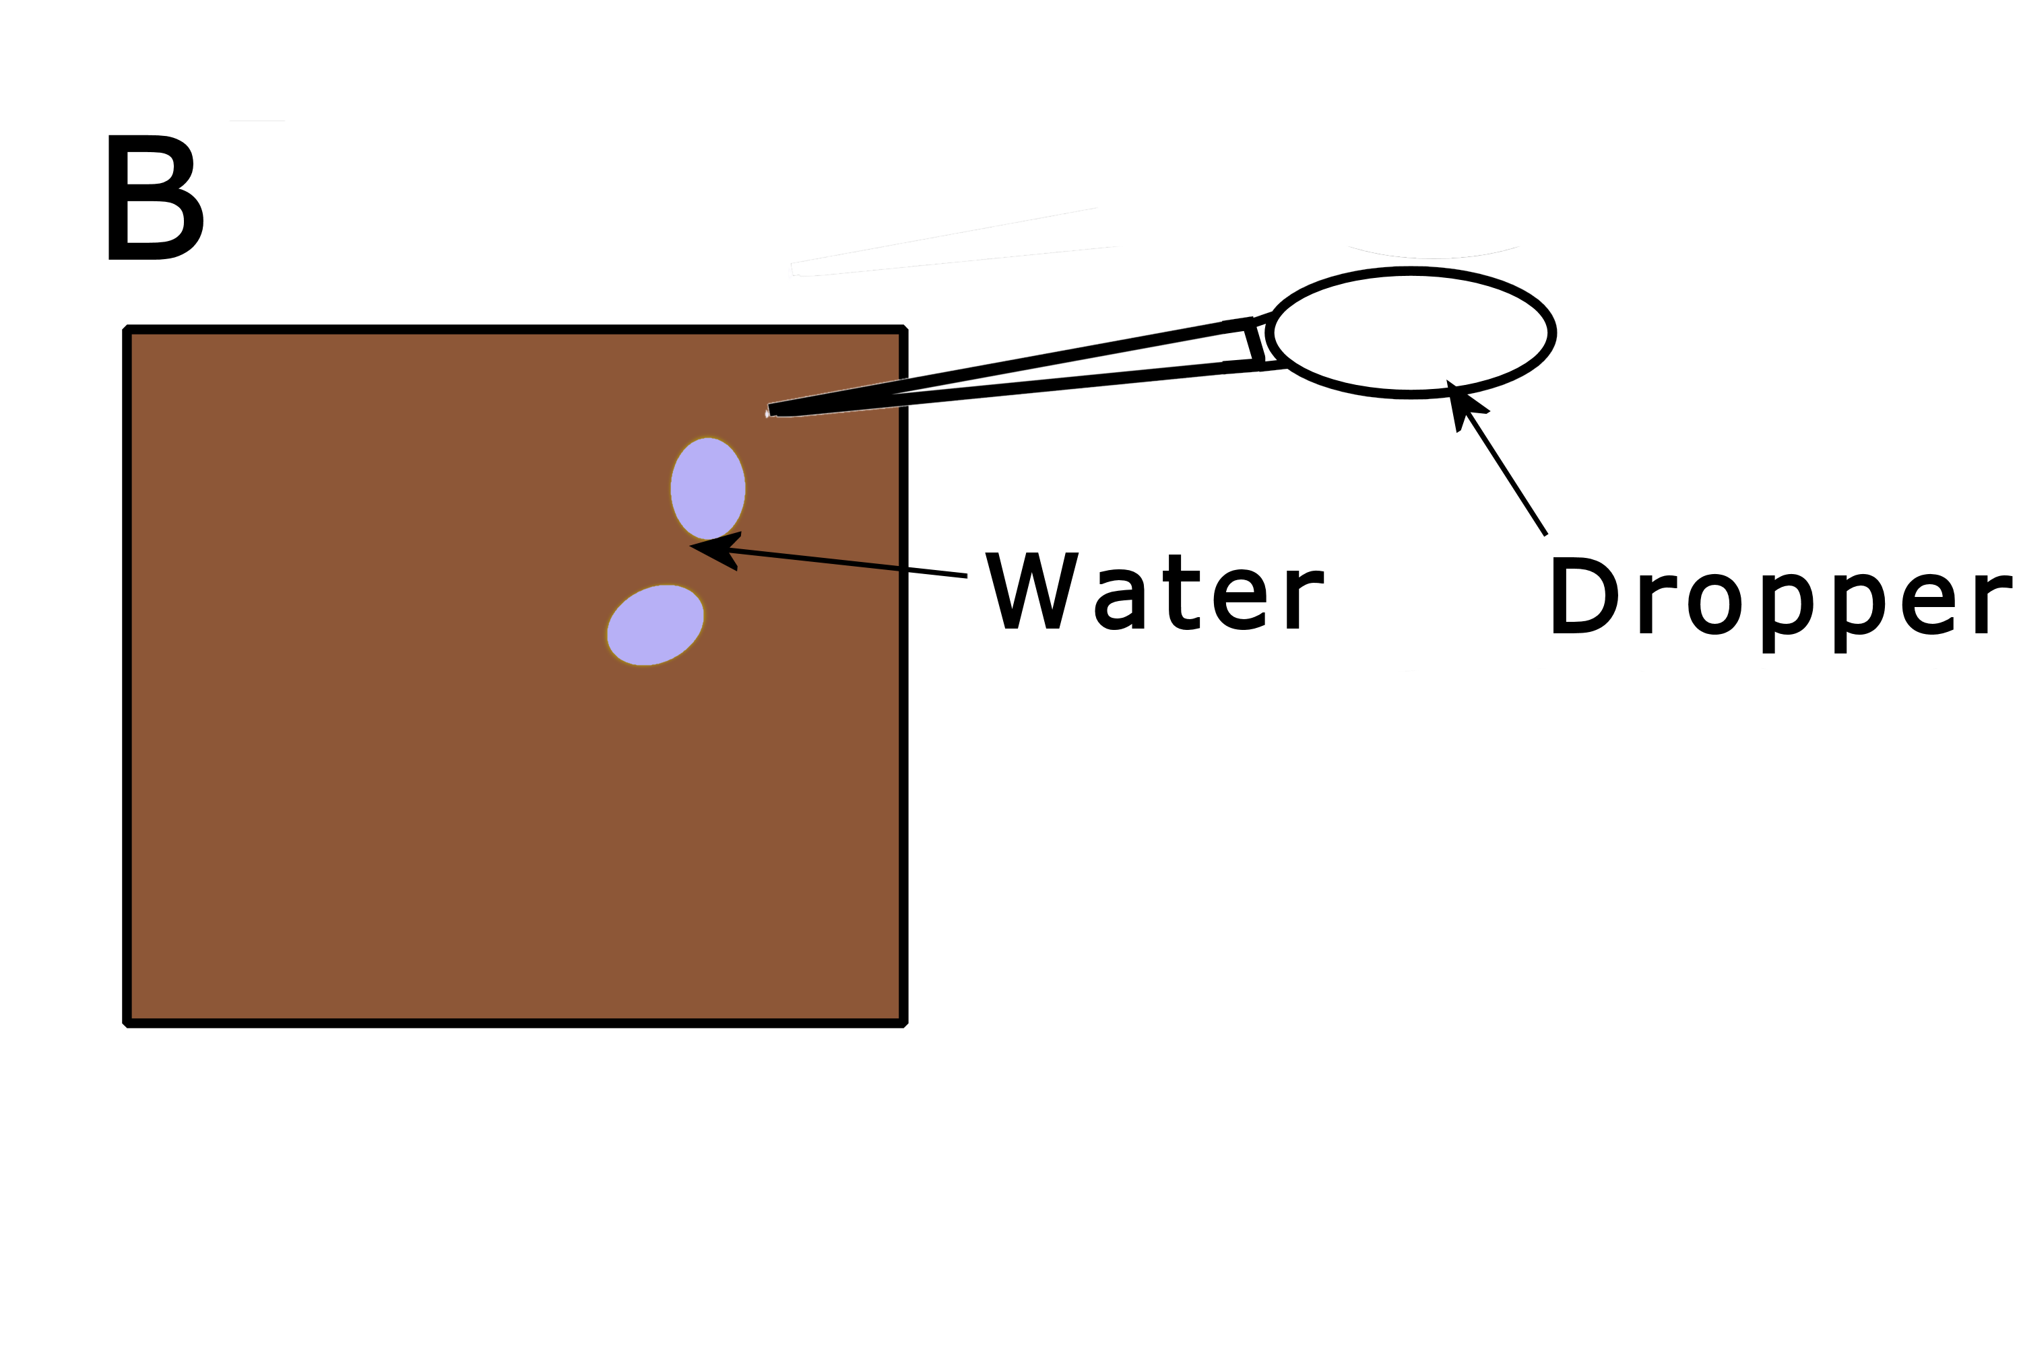
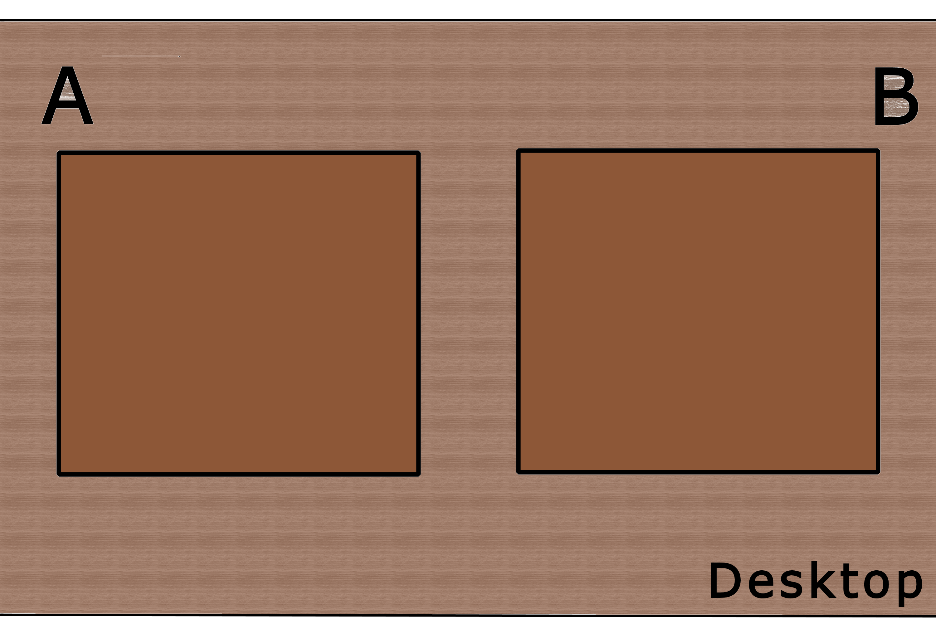
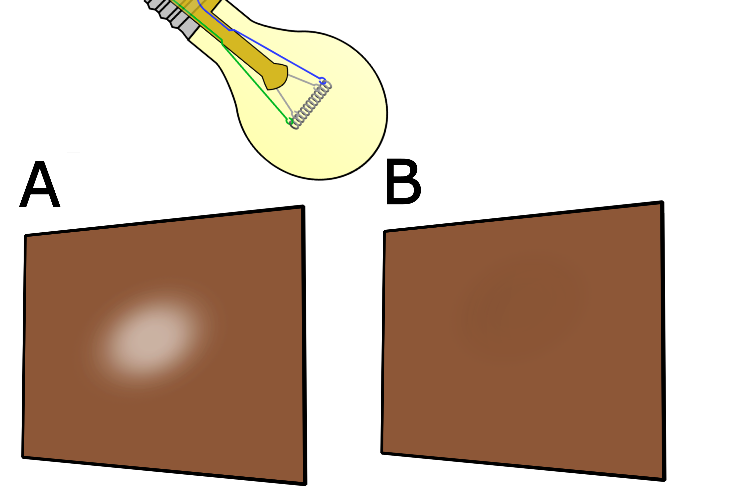
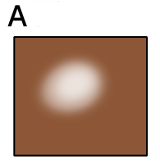
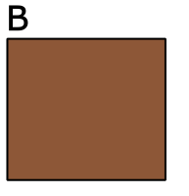
1.
2.
3.
Cut two pieces of brown paper to similar size.
Place 2-3 drops of oil on paper A.
Place 2-3 drops of water on paper B
Leave both pieces of paper to dry..
Hold both pieces up to the light when dry.
4.
5.

Always remember – Leave time to tidy up

Expected Result
Positive:
translucent spot
Negative:
no
translucent
spot

Sample | Final appearance
A –Oil
B – Water

Now test various food samples and record your results

Food | Result

Conclusions

