COMPREHENSION EXERCISE 2
Read the following passage and then answer the questions that follow:-
Winter Vomiting Bug
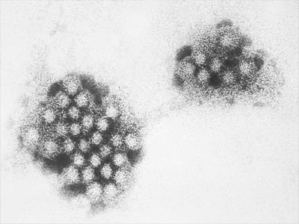
Noroviruses are small RNA viruses which cause winter vomiting disease which is characterised by the rapid onset of violent episodes of “projectile” vomiting and diarrhoea. Most patients recover after 1-2 days although they may remain infectious by continuing to shed the virus for several days after symptoms have finished. In the USA, the Centre for Disease Control has shown that more than 50 % of food borne outbreaks of gastroenteritis are linked to norovirus. In Europe it has been estimated that more than 80% of all non-bacterial food borne outbreaks of gastroenteritis are due to norovirus.
As few as 10 virus particles may be enough to cause illness. Noroviruses can enter the food chain at many points. Noroviruses spread by person to person contact and by contact with particles of aerosolised vomit on surfaces/in the air. Another source of infection is via food handlers. Contaminated serving utensils, often shared at buffets, also provide a very effective method of spreading noroviruses. Shell fish can also become contaminated where sewage causes water pollution. Shell fish e.g. oysters, are filter feeders and huge numbers of virus particles may build up in their tissues and if eaten raw, can lead to very rapid onset of symptoms.
There are currently no licensed vaccines or anti-viral treatments for noroviruses so prevention is essential. Good hygiene, frequent hand washing and decontamination of food preparation areas, vessels and utensils can all reduce the frequency of outbreaks. Staff affected by the disease are advised not to return to work for several days after recovery.
(Based on Beware the Buffet in Microbiology Today Aug 2010)
- What is winter vomiting disease caused by?
- Give two symptoms of winter vomiting disease.
- What percentage of gastroenteritis cases are due to norovirus in the USA? In Europe? Suggest a reason for the apparent difference – from the passage.
- What is the term for a disease causing organism?
- List three methods by which noroviruses are spread.
- Explain the underlined term.
- Noroviruses are RNA viruses. What other biomolecule is present in noroviruses?
- Detail the method of replication of a virus.
- Why are buffets more likely to lead to an outbreak than other types of meals?
- Why are affected staff advised to remain at home for several days after they have recovered?
- Describe in detail how a vaccine produces immunity without causing disease
- “As few as 10 particles may cause illness.” Why was the term “particle” and not “cell” used?
- “Viruses are on the border between living and non-living.” Discuss.
Check out this website (http://www.diseasedetectives.org/deeper) for more information on norovirus and other diseases.

