4.6 To prepare one enzyme immobilisation and examine its application
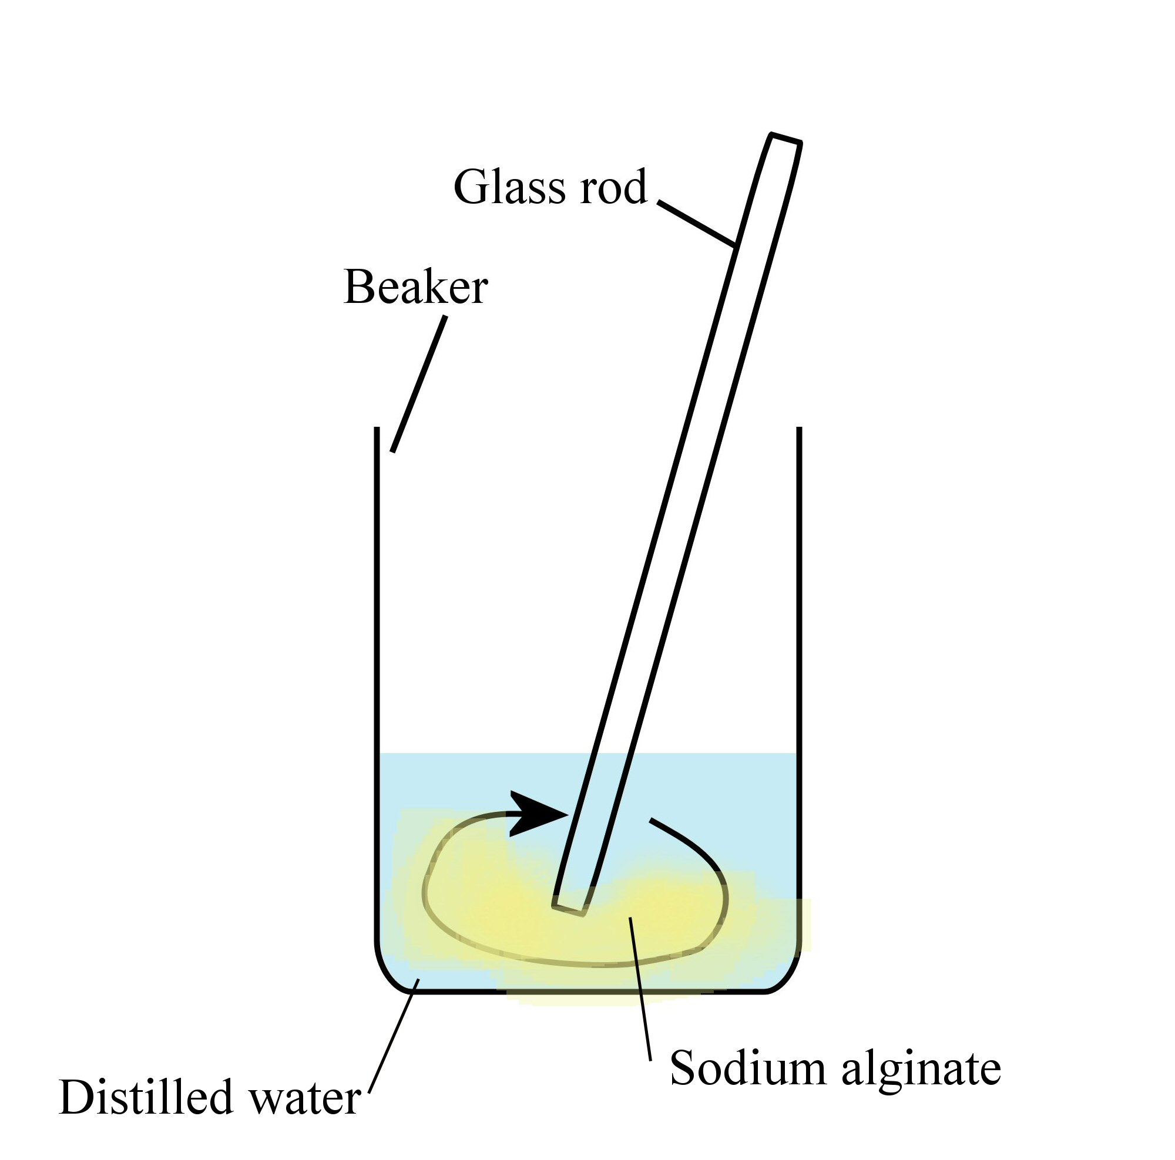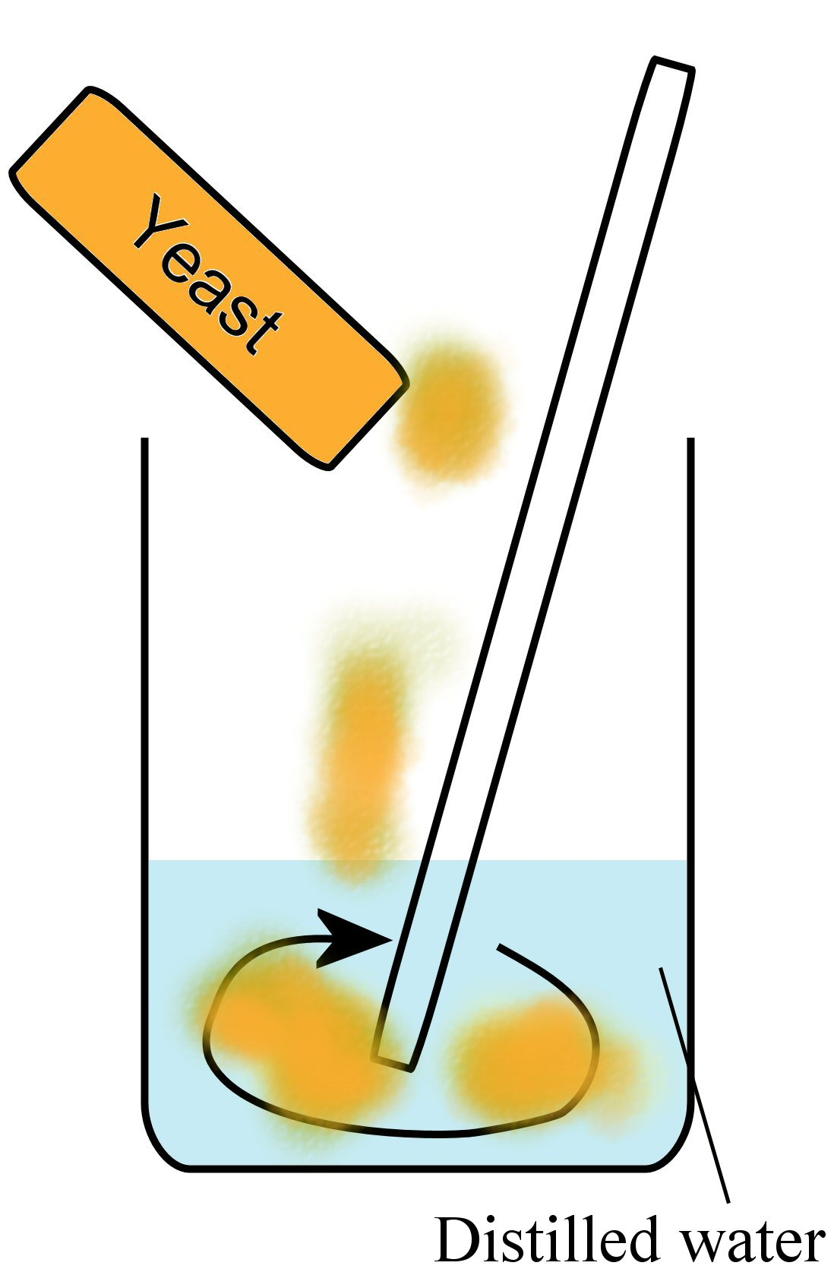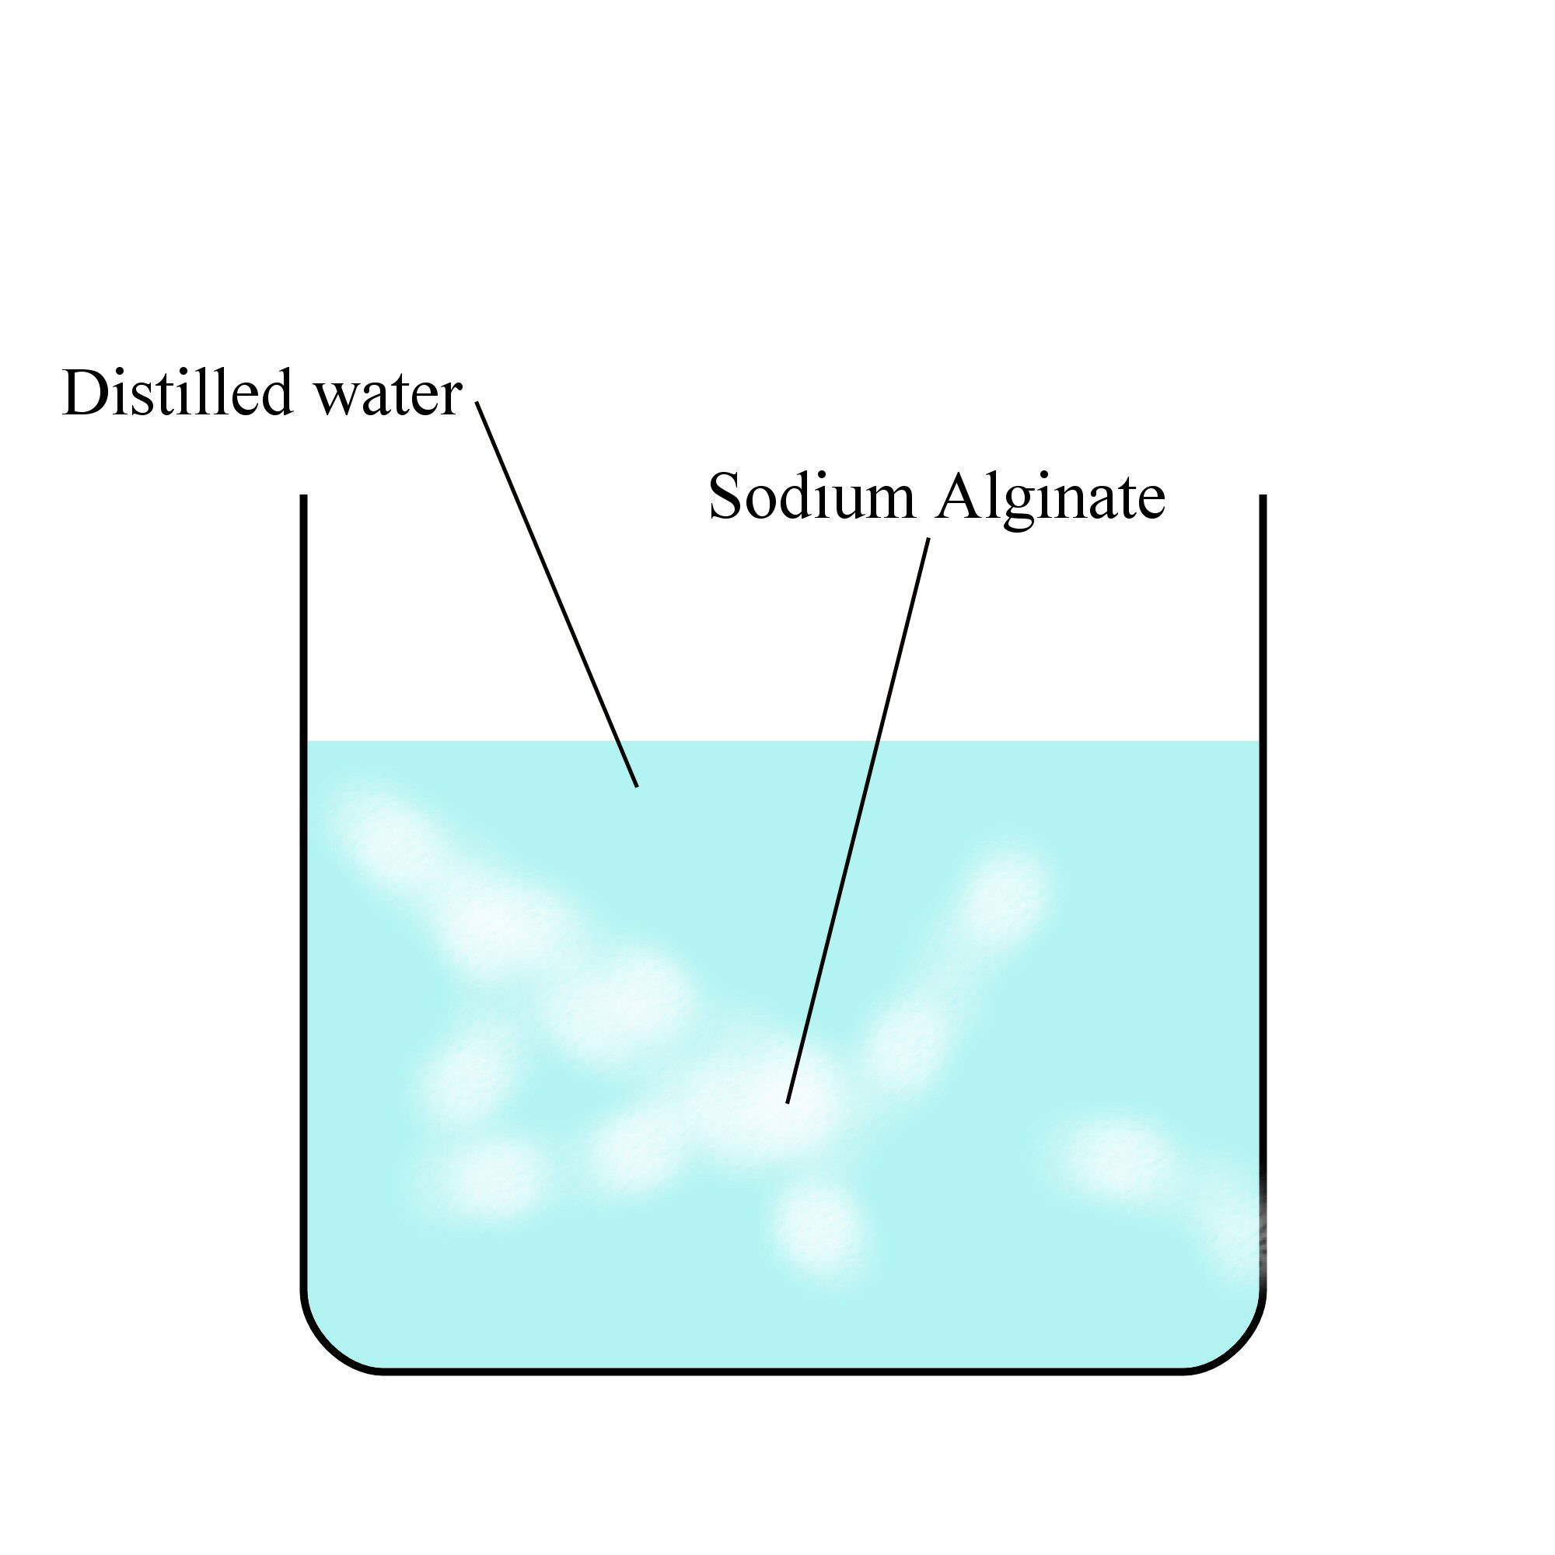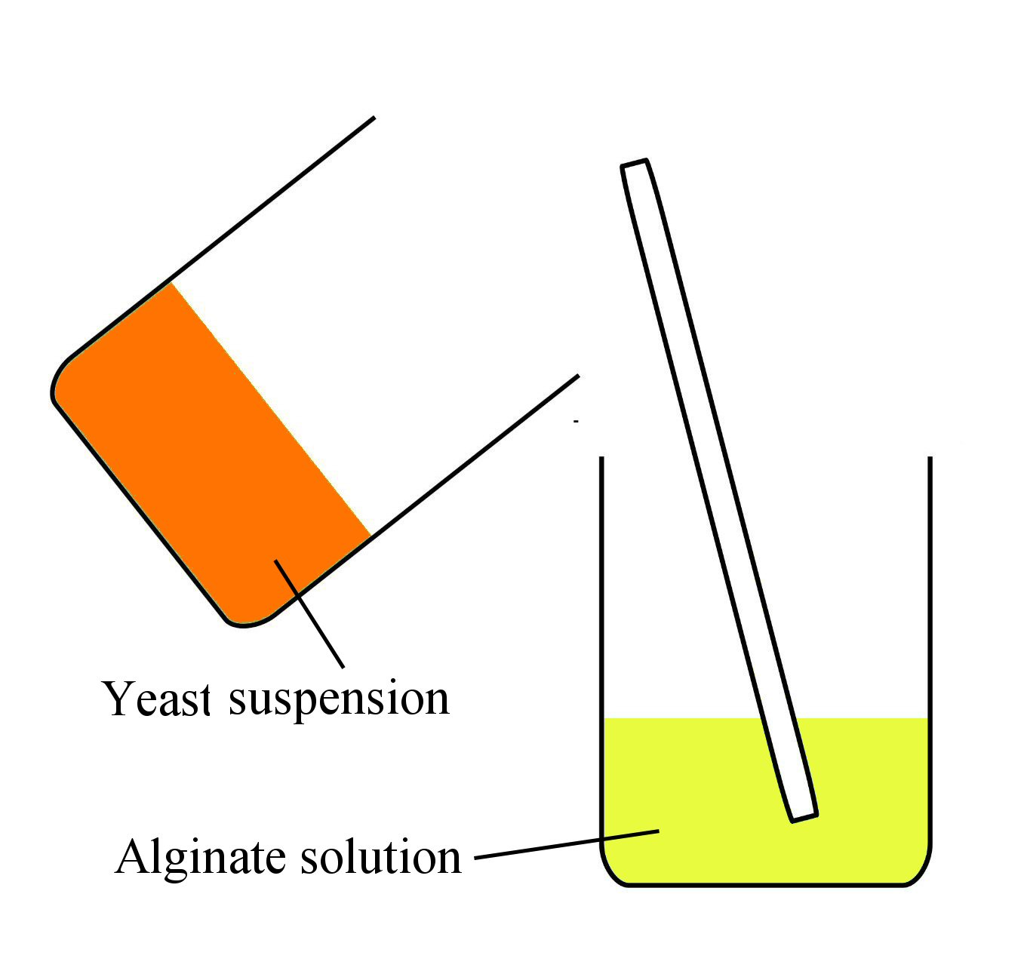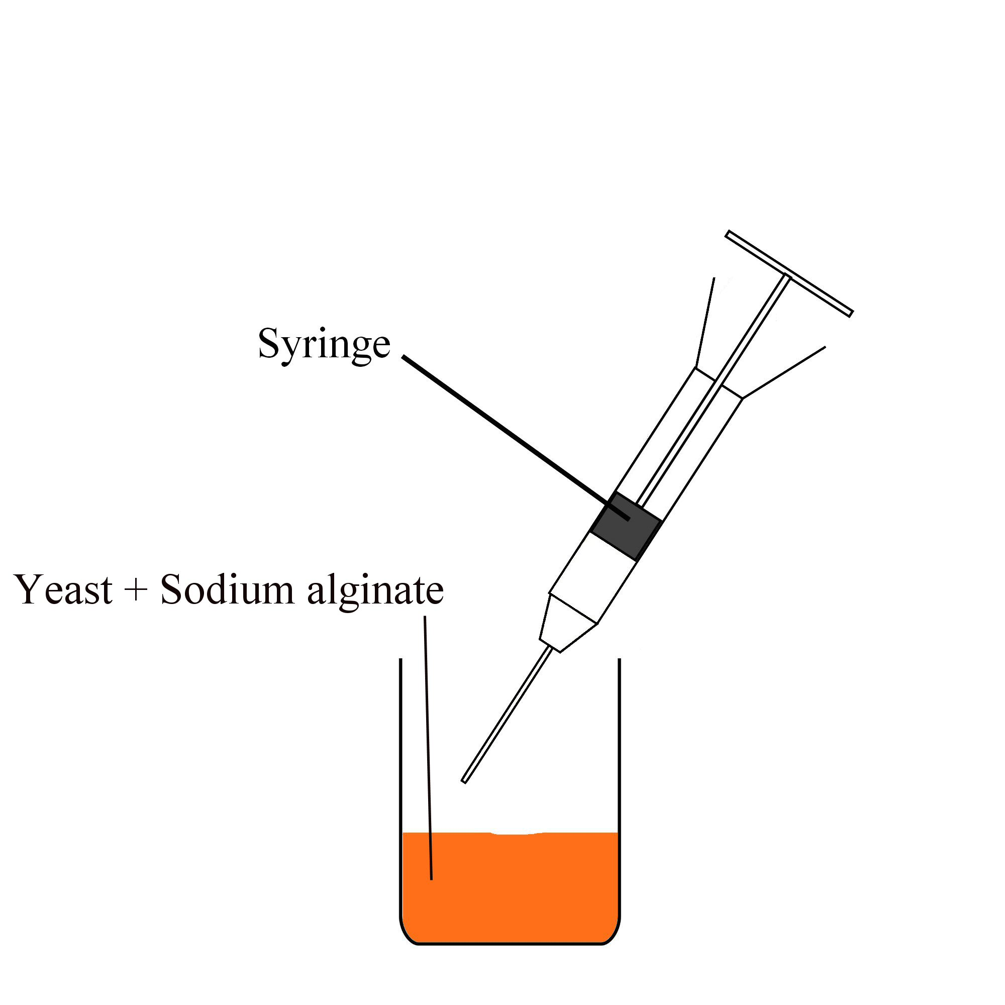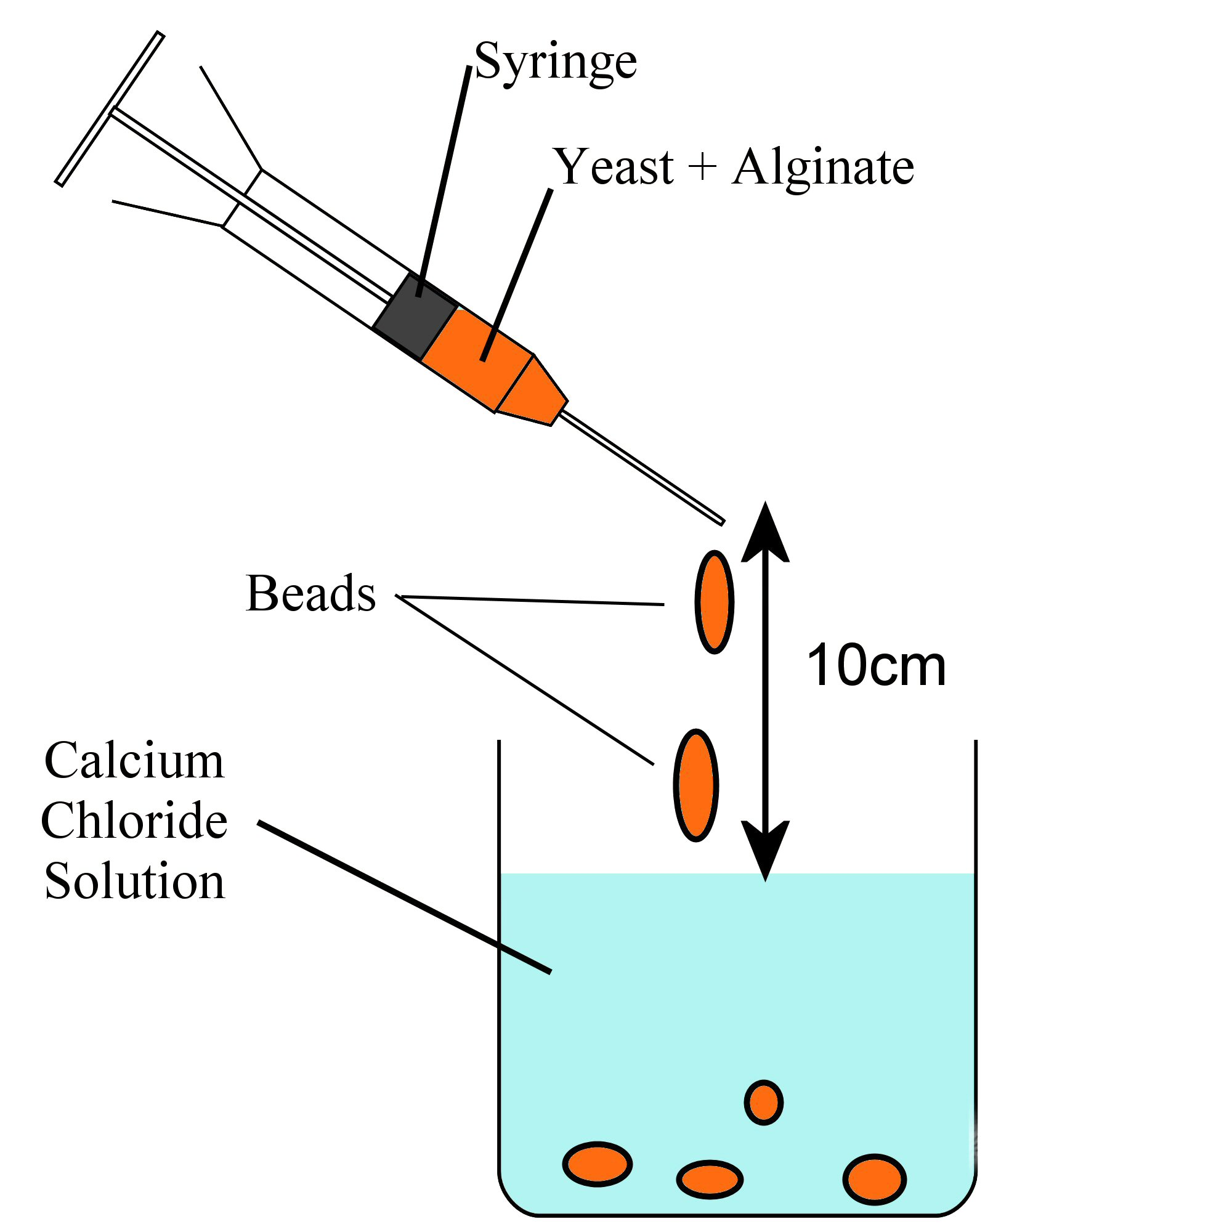
1.
2.
3.

Always remember – Leave time to tidy up

This page can be printed in colour from the accompanying CD
In a beaker, add 0.4 g sodium alginate to 10 ml of distilled water and stir.
In a separate beaker, add 2 g of yeast to 10 ml of distilled water and stir.
In a separate large beaker, dissolve the calcium chloride in water.
5.
4.
Add the yeast suspension to the alginate solution.
Draw the liquid into a 20 ml syringe.

6.
From a height of 10 cm, release the mixture from the syringe into the calcium chloride one drop at a time. Leave to harden for 10 minutes.
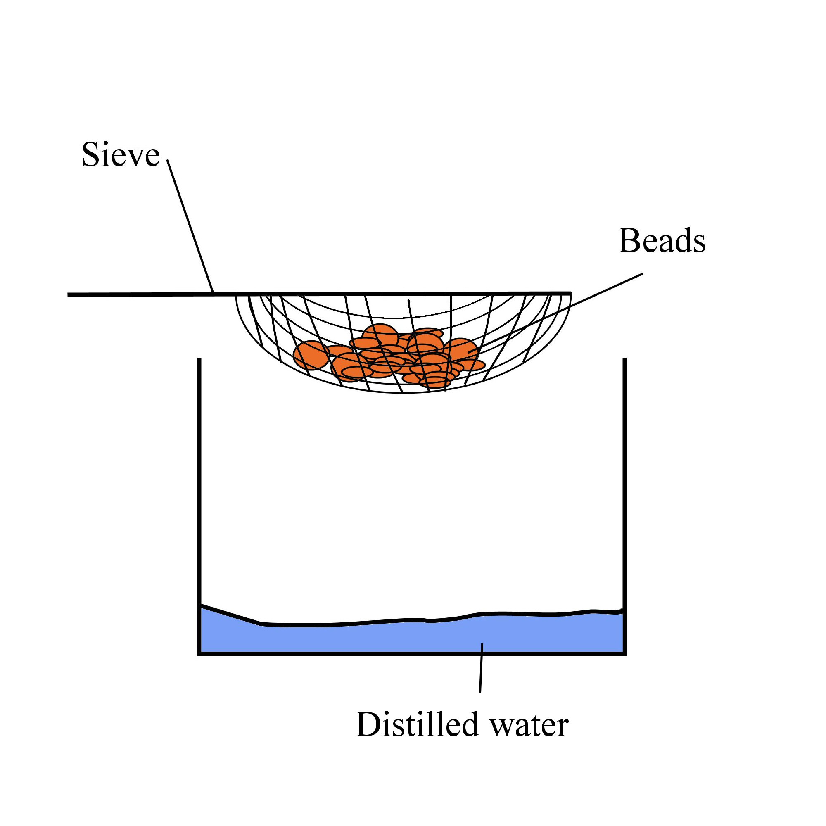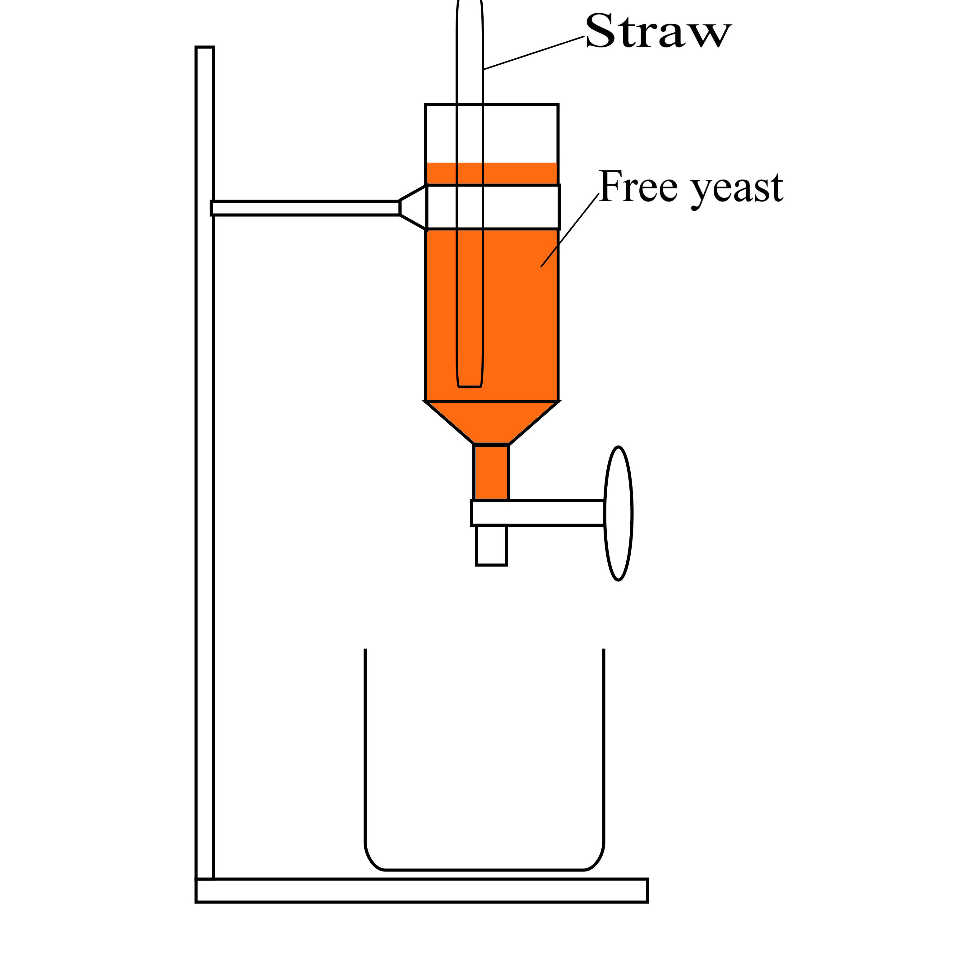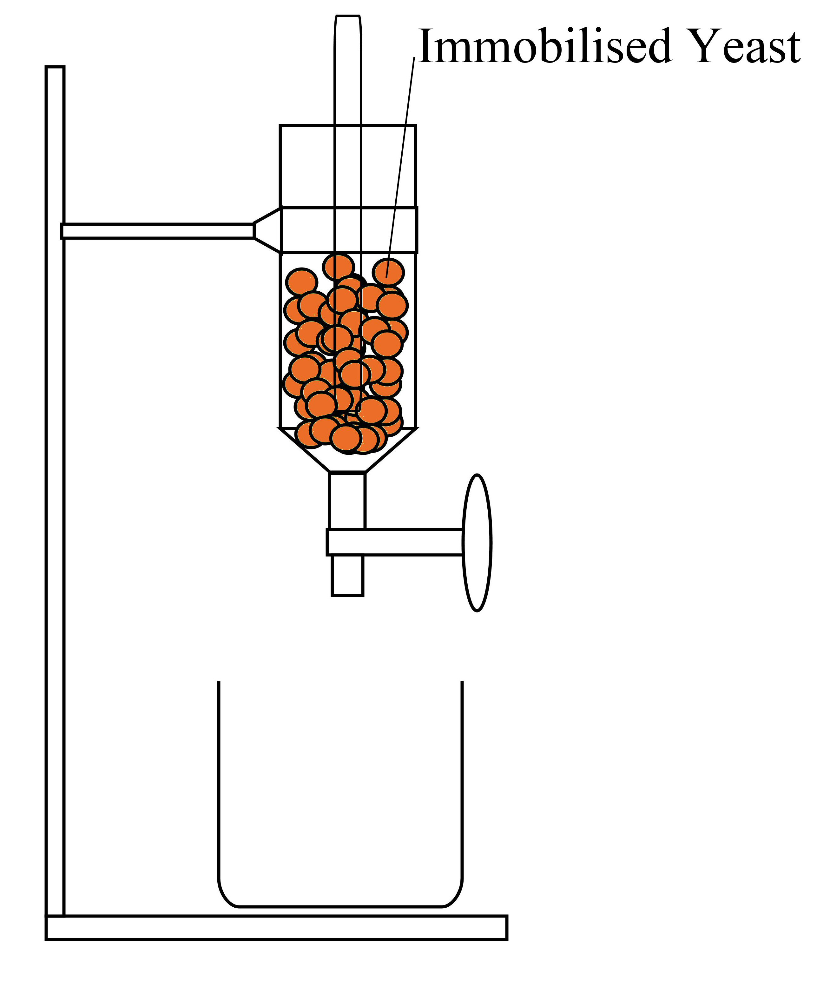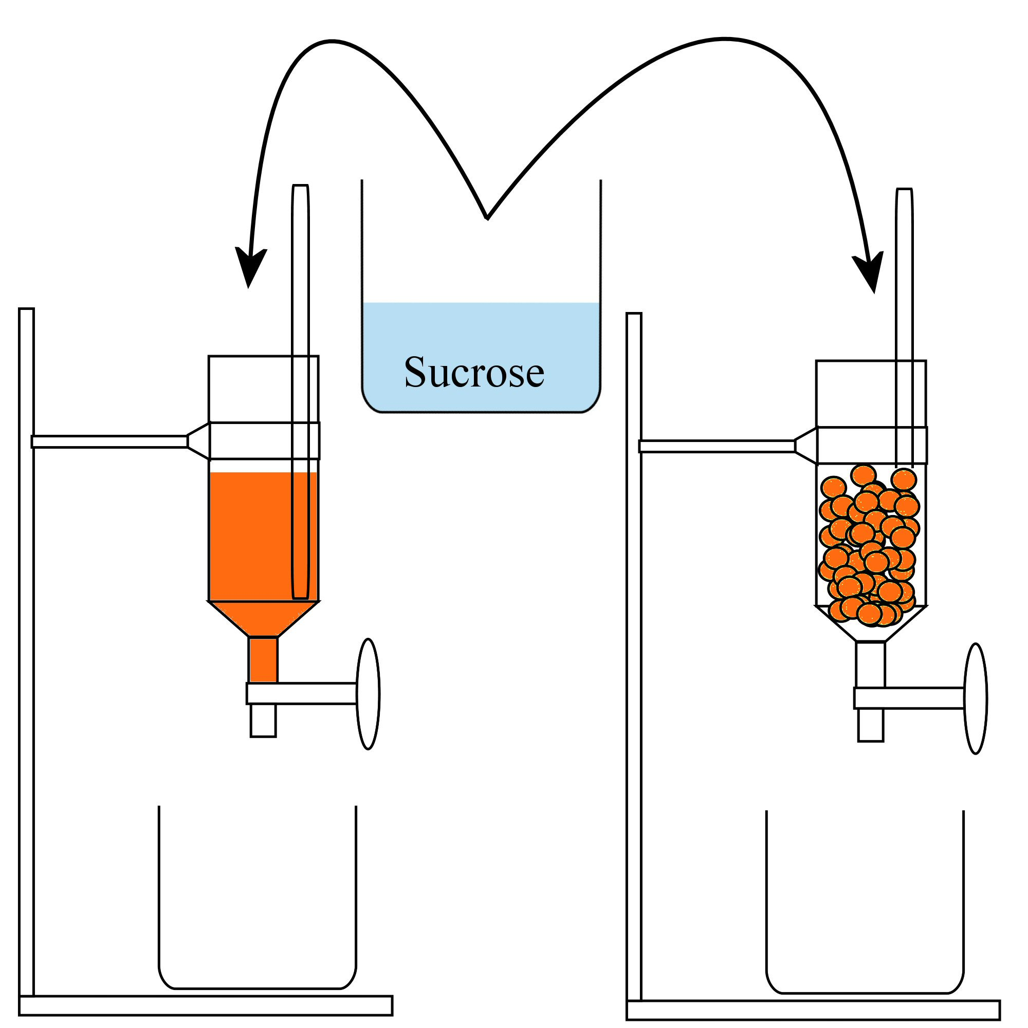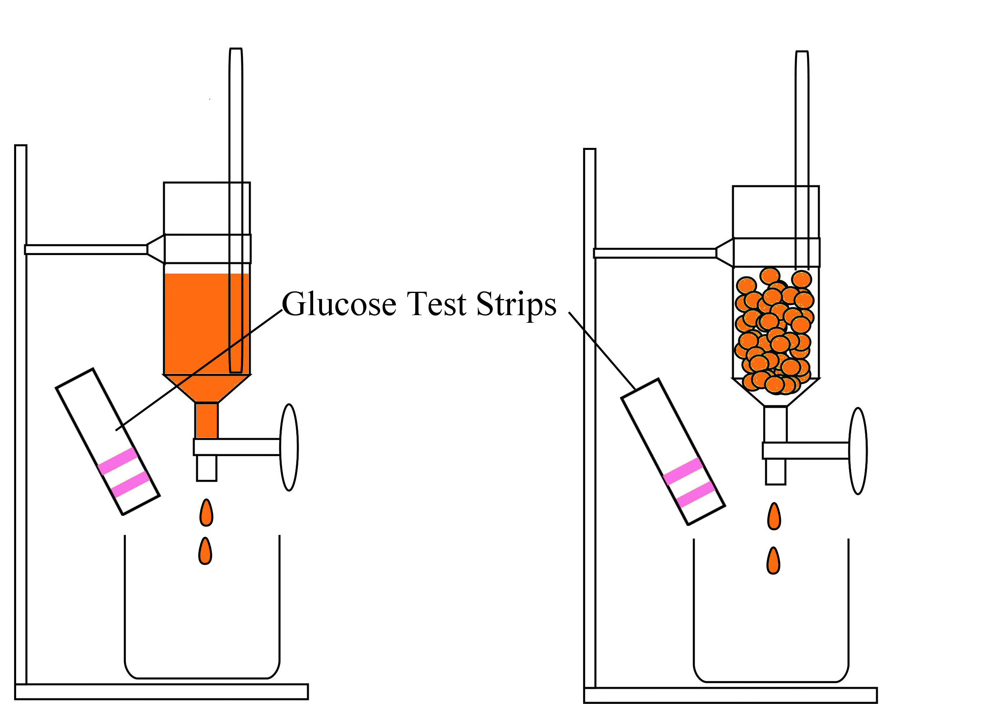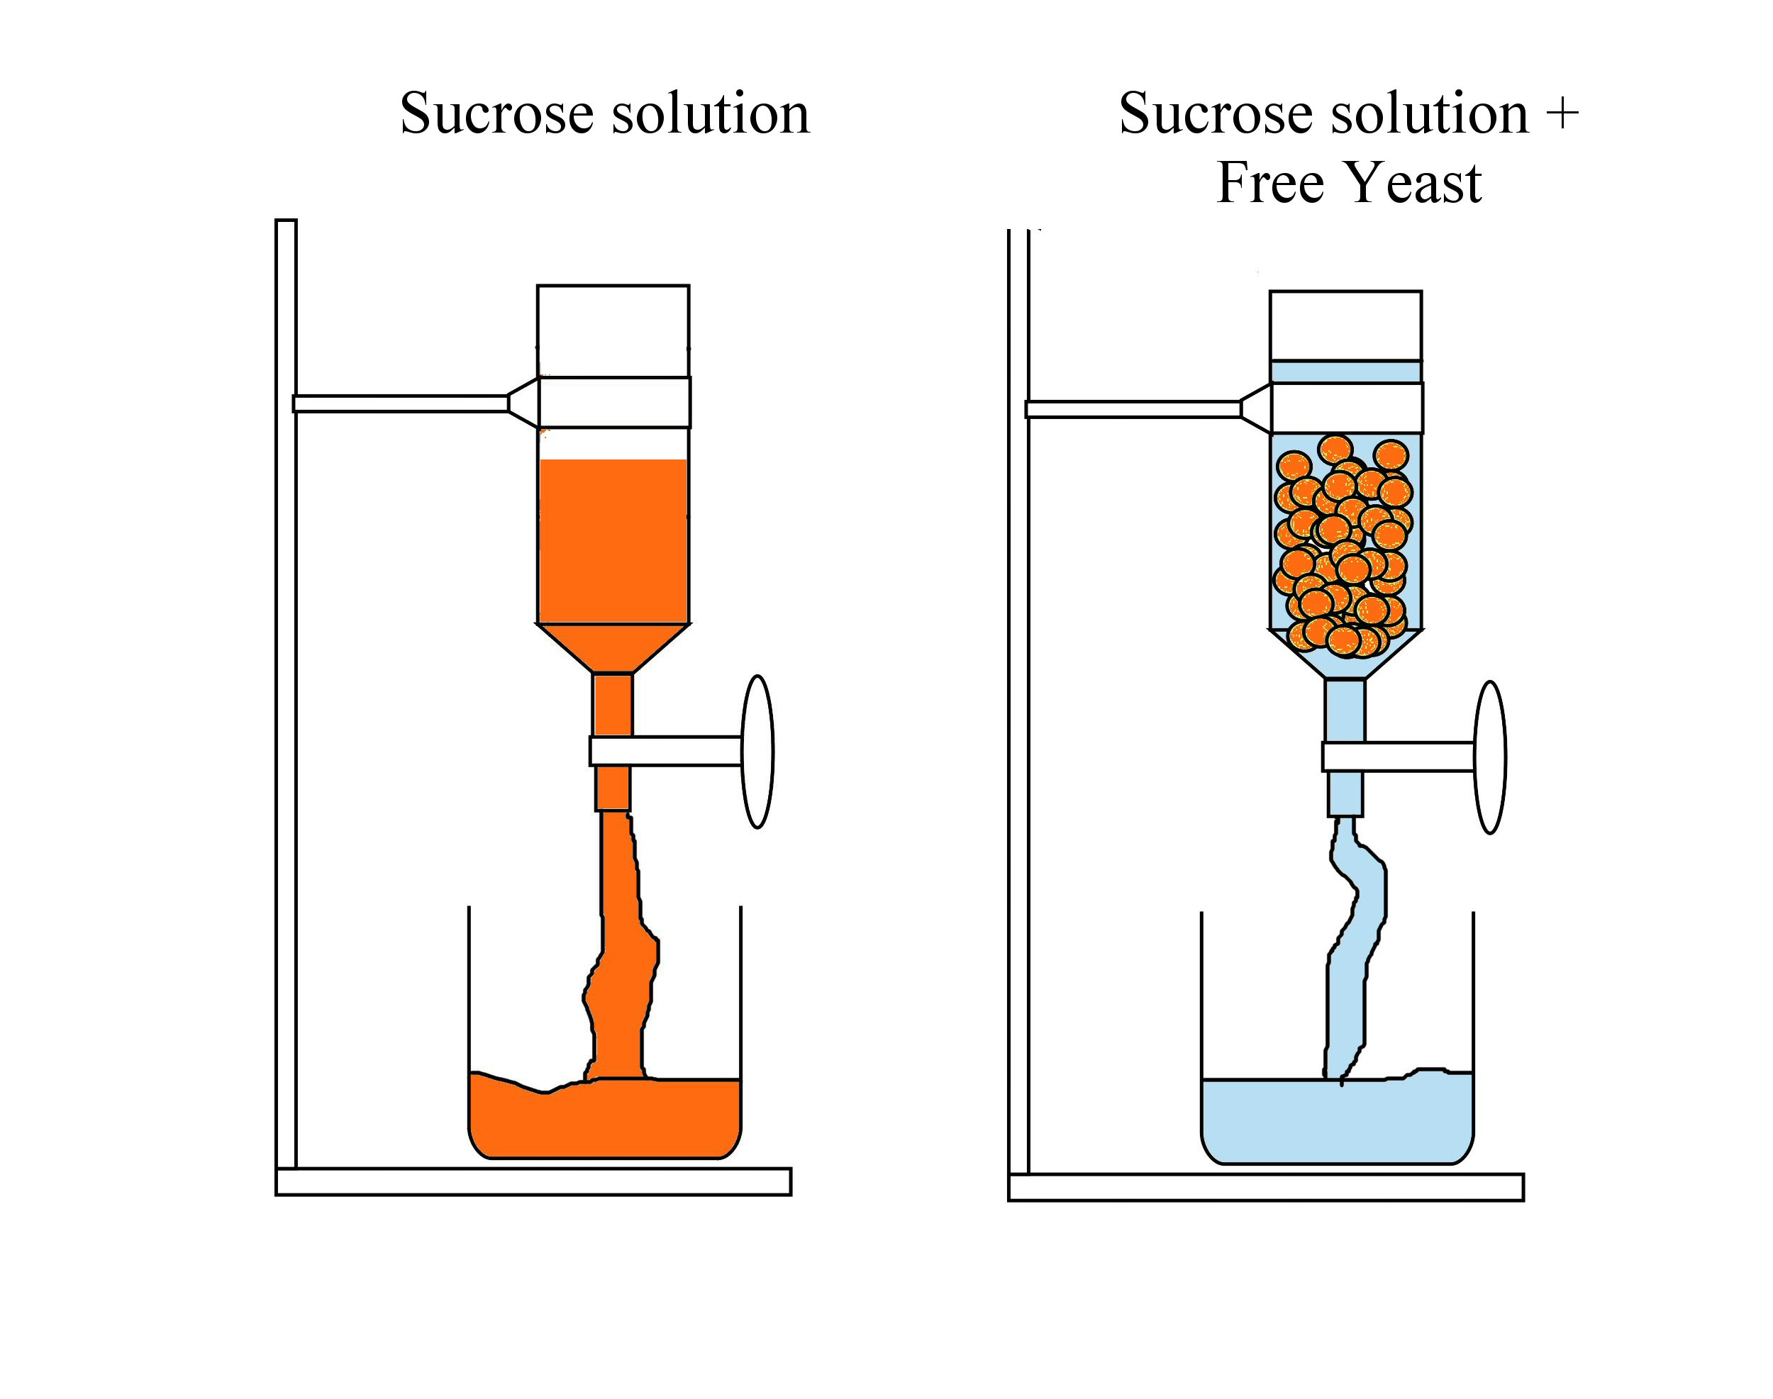
7.
8.
9.
This page can be printed in colour from the accompanying CD
Filter the hardened beads through a sieve and rinse with water.
Mix 2 g of yeast in 10 ml of distilled water and pour into one of the separating funnels.
Pour the beads into the second funnel.
10.
Dissolve 1 g of sucrose in 100 ml of distilled water. Pour 50 ml into each separating funnel.
11.
Immediately test the products in the beakers with glucose strips.

12.
Repeat test every 2 minutes until glucose appears in both beakers.

Always remember – Leave time to tidy up
13.
Run off the remaining product from each funnel into the beakers and compare the turbidity* of the solution from both funnels.
* Turbidity – cloudiness of solution
Time  (minutes) | Free yeast – presence of glucose | Immobilised yeast – presence of glucose
0
2
4
6
8
10
/////////////////////////////////////// | Free yeast | Immobilised yeast
Turbidity of solution
Table of results:
This page can be printed in colour from the accompanying CD

Always remember – Leave time to tidy up

